**SECURE CODING LAB 1**

**MEGHANA CILAGANI**

**19BCN7157**

Creating folders,txt files,docx files.

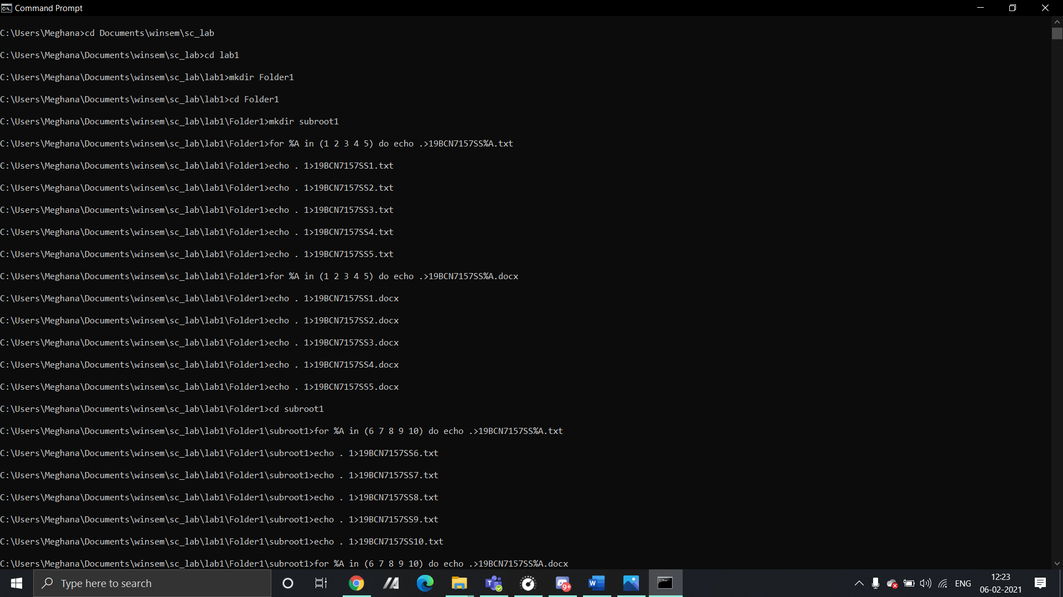

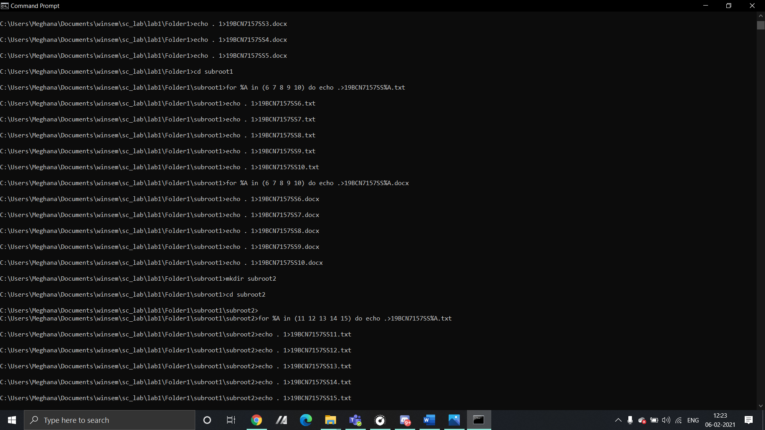

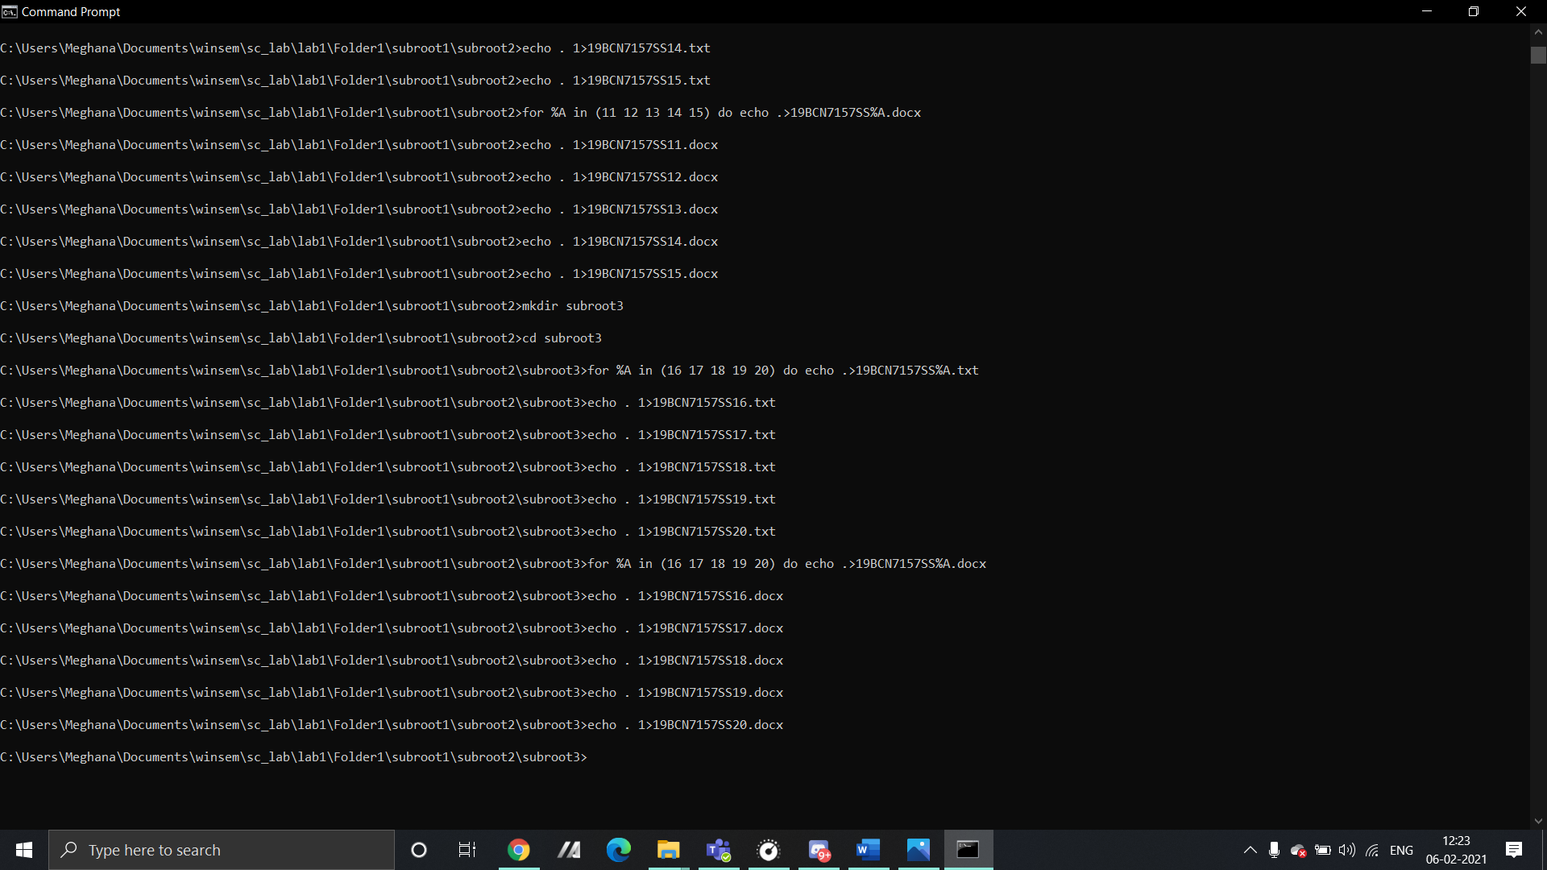

1)Delete all the files from the last child.

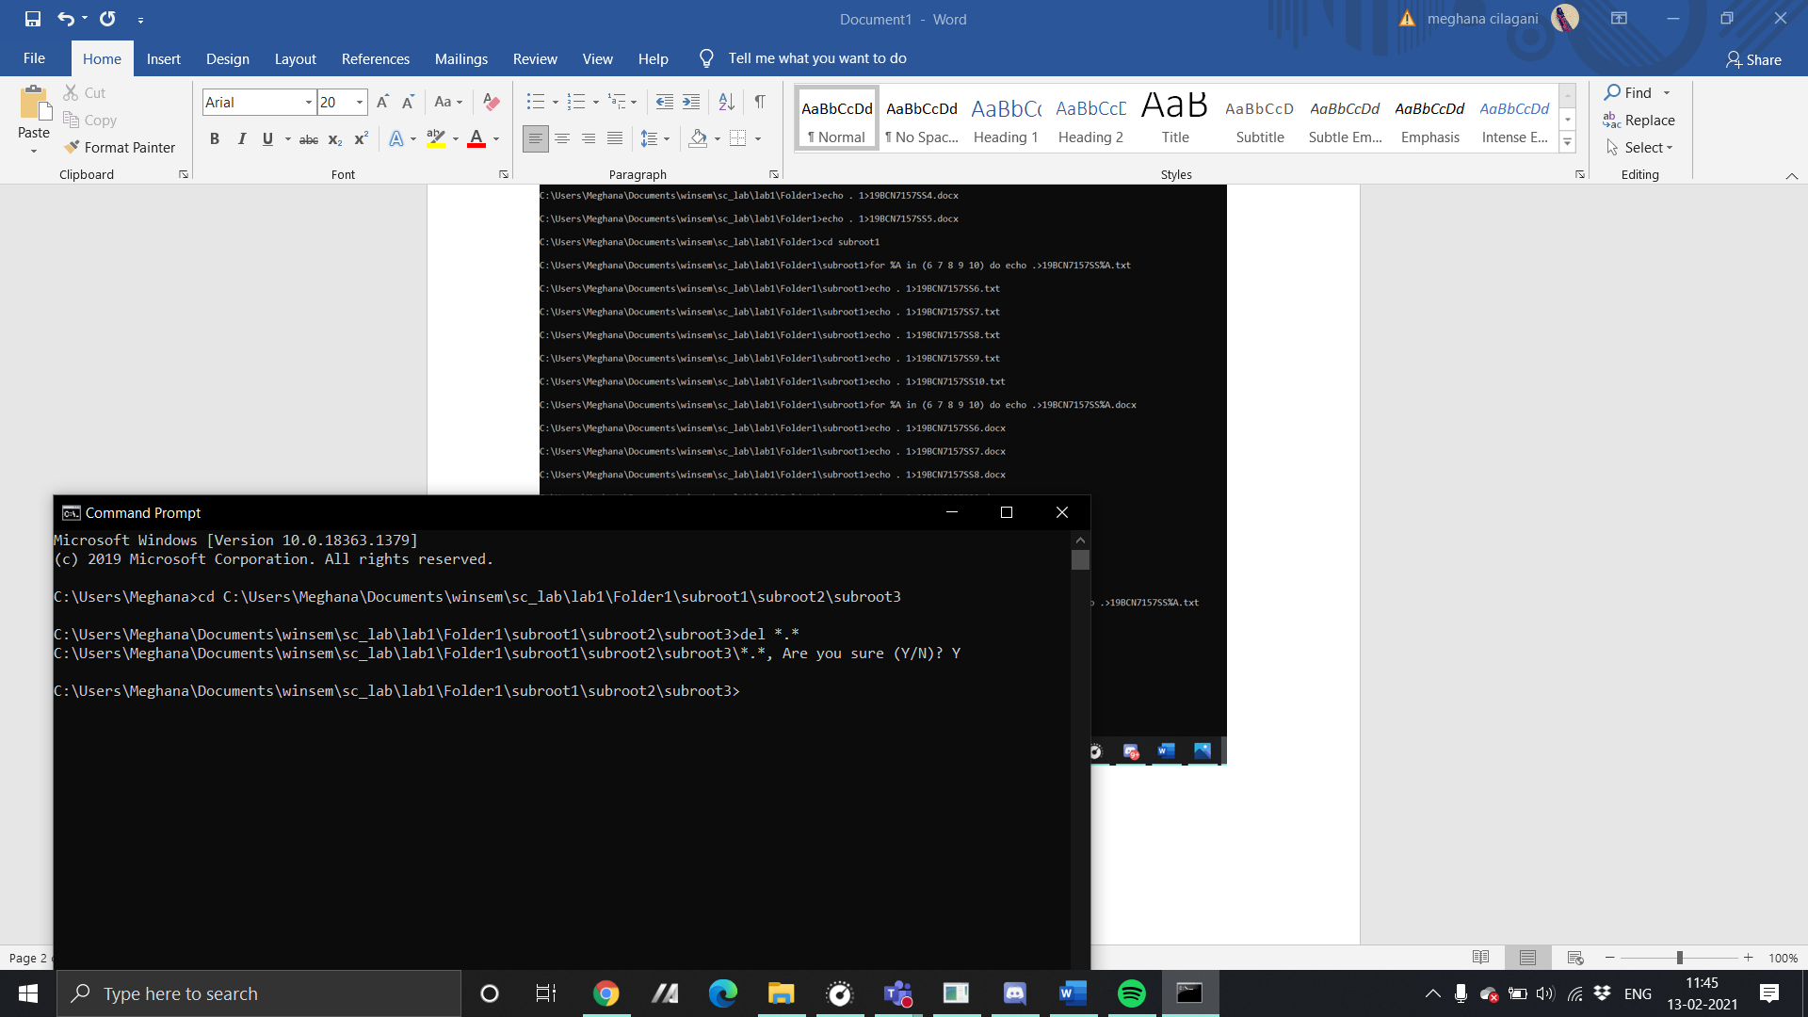

delete files of docx type.

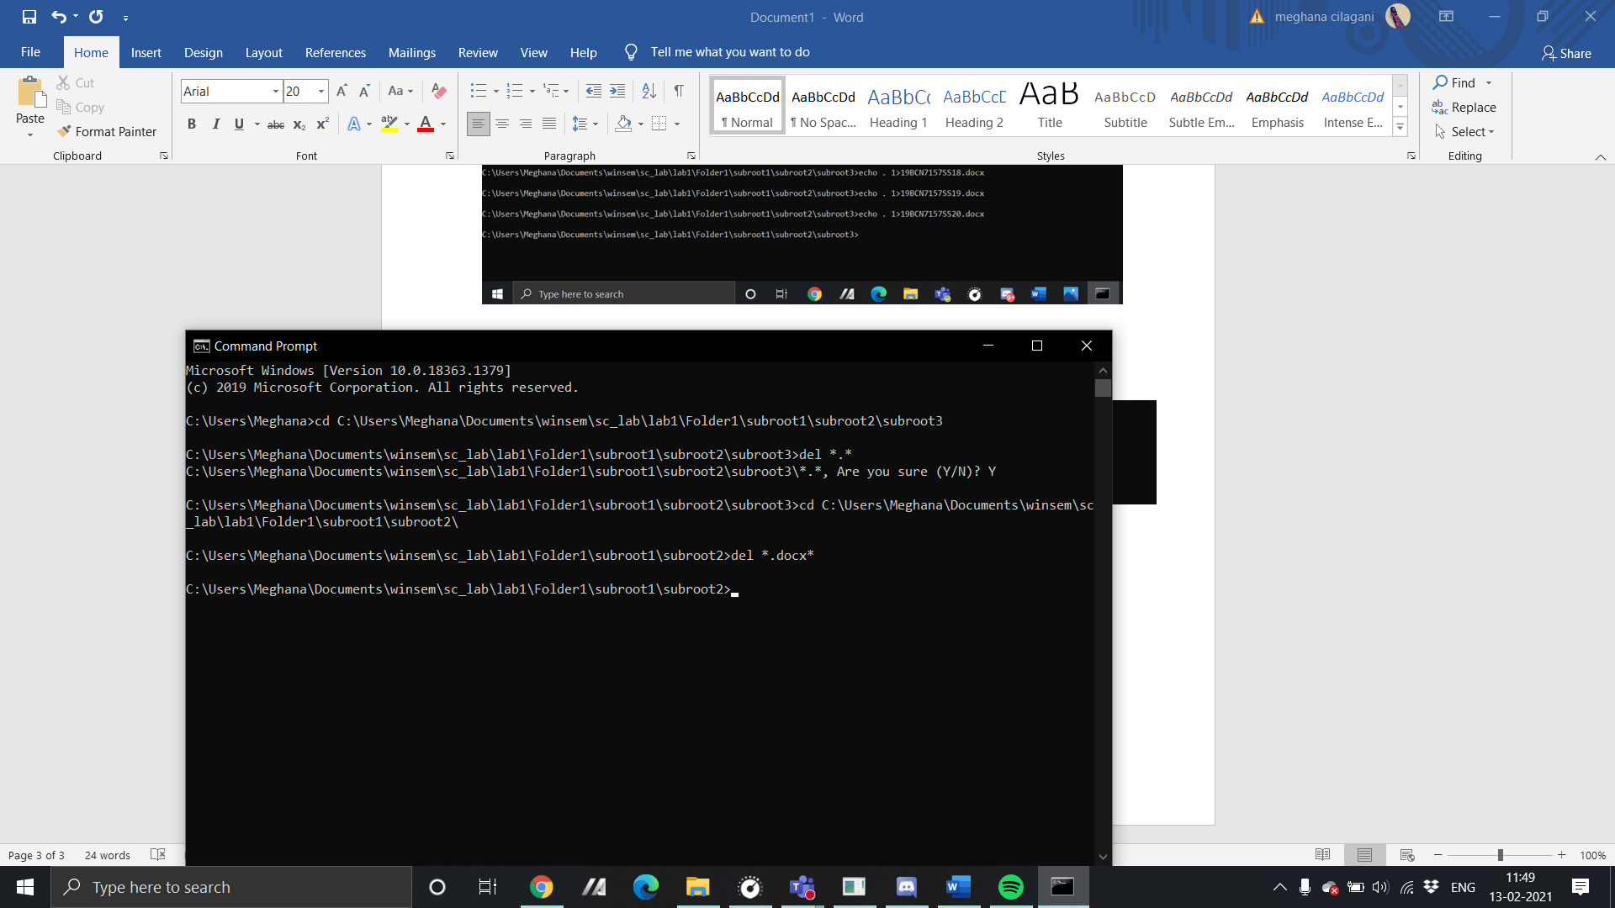

3)delete all files of .docx type starting with ss.

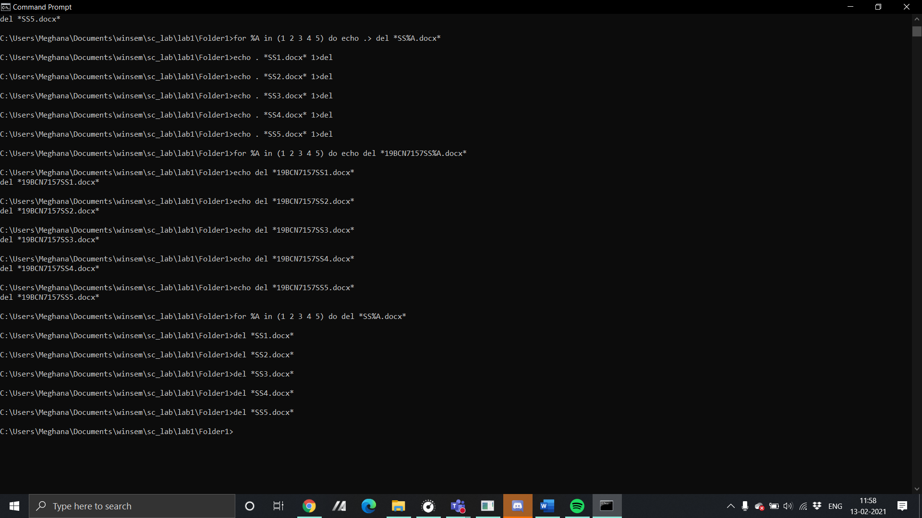

4)delete files from ss11 to ss19.( I here deleted files SS8 to SS10 as I had deleted SS11 to SS19 in the previous question)

